Artifact



Game Manual

1. Introduction

Concept: The concept of the game Artifact is that you play an archeologist during the “golden age” of archeology from 1900 – 1950. You are an archeology professor that is competing with rival players to discover the most legendary historical artifacts across a spectrum of cultures. You will need to research, explore, scheme and strategize to collect the most valuable finds!

Objective: the player who collects the most victory points by the end of the game is the victor. Victory points represent the status of the professor, and are accumulated by exploration, defeating monstrous foes and conducting archeological digs to unearth artifacts.

Components of the Game:
- 1 Major Action Board
- 1 Academy Board
- Money chits
- 4 Professor pieces
- Research Assistant pieces (5 for each player)
- Resource Point (RP) chits
- Artifact Cards (37 Americas, 37 Eurasia, 37 Middle East, 5 Legendary)
- Hazard Cards (18 Tenured, 18 Doctoral, 18 Arcane)
- 40 Scheme Cards
- 64 Explore Cards
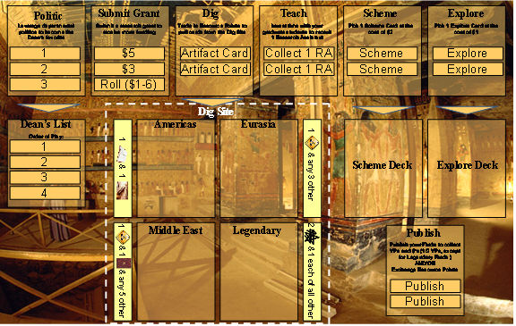
Major Action Board
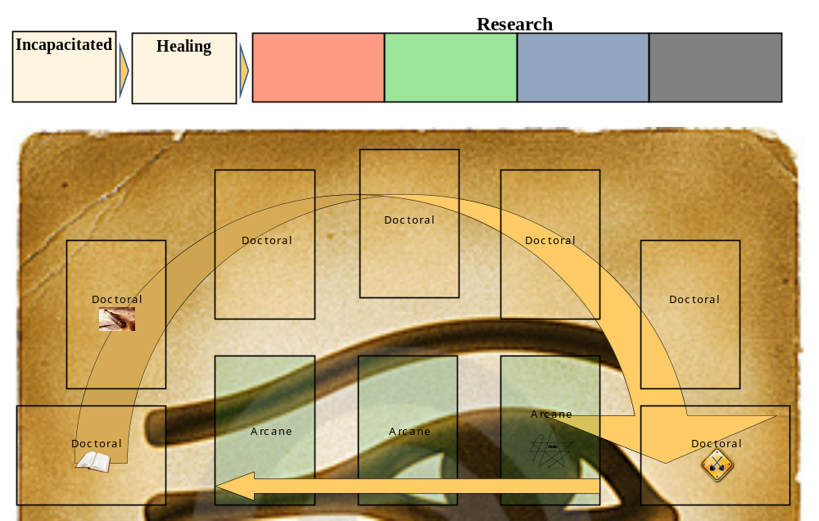
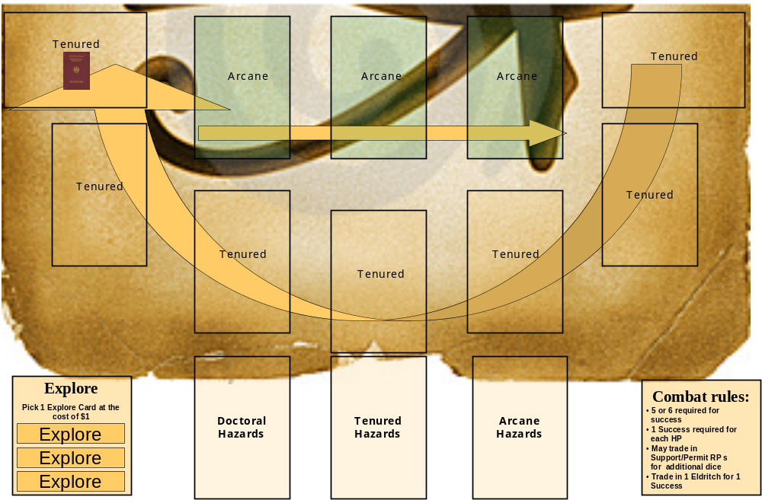

The Academy Board

2. Game Set Up
At the beginning of the game, set up the board with each stack of cards placed in their designated spots (e.g., the Americas deck goes where it says “Americas,” Explore deck where it says “Explore,” etc.). Make sure each deck is well shuffled. If more than 2 players are playing, the Academy Board receives the following:

- 3 players: 1 Scholastic Resource Point
- 4 players: 1 Scholastic RP, 1 Field Resource Point

Place these additional Resource Points on the board in the doctoral zone, placing each on the tiles to the left of the pre-printed RPs, going moving clockwise around the board.

Each player chooses a color, and begins play with:
- 1 Professor and 1 Research Assistant (RA) piece
- Each player starts with $3
- Active RAs go onto the Research bar at the top of the Academy board

A die is rolled to see who goes first; the player with the highest roll is first on the Dean’s List, with the players to his left going second, third, or forth.

3. Sequence of Play
The game is divided into turns that have a defined sequence of play. Each turn, the following sequence of play is observed:

- Collect Income: collect $1 in income
- Choose Major Action: place Professor on a Major Action tile
- Conduct Research: place Research Assistant(s) and/or Professor on Academy tiles
- Resolve RA Actions: remove Research Assistants from the Academy Board and collect Resource Points; resolve RA explore phase
- Resolve Professor Actions: remove Professors from the Major Action board, and resolve actions from left to right starting with Politic and ending with Publish
- Heal Professor or RAs: Move incapacitated RAs or Professor to healing, collect healing RAs/Professor

3.1 Collect Income
Collect $1 in income. Players with Patrons or Stipends also collect their additional incomes at this time.

3.2 Choose Major Action
Starting with the first player, place Professor on one of the Major Action tiles. Some Actions have a limited number of slots and thus cannot be chosen by all players. Major actions include:

- Politic - play departmental politics to go 1st, 2nd or 3rd on the subsequent turn
- Submit grant – collect $5, $3 or roll a die and collect $1-6
- Dig – trade in Resource Points for Artifact cards. Buy as many Artifact cards per turn as you have Resource Points available
- Teach – receive another Research Assistant, up to a maximum of 5
- Scheme – pay $2 to draw a Scheme card. Scheme cards allow the player to sabotage other player’s effort, and also protect against such meddling.
- Explore – pay $1 to draw an Explore card. Explore cards create encounters with a variety of monsters, friends and foes
- Publish findings – play Artifact Cards from your hand face-up onto the table. Collect the specified number of victory points in the upper right hand corner. Also, collect half the number of VPs in cash. You may also can “trade up” on resources as per the following: 1-1 for scholastic/field, 2-1 for anything to support, 4-1 for permits, and 8-1 for eldritch
- Research – place Professor piece on the Research icon, and use it as you would an RA. The only difference is that Professors are played for free and can chose NOT to collect a Hazard card. They may do so if they wish to.

3.3 Conduct Research
The Academy offers the option to collect a number of different types of resources, including:
- Scholastic research (book icon) – the most common type of resource
- Field research (map icon)
- Site support (shovel icon)
- Dig permits (document icon)
- Eldritch research (pentagram icon) – the least common type of resource




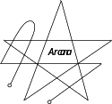

Starting with the first player, place 1 RA per turn in, until all RAs have been placed. NOTE: if you chose Research as a Major Action, plays your Professor first, prior to playing your RAs.

The first tiles that are playable start in the “Tenured” zone. Playable tiles expand as Breakthroughs are added to the board. There are several Resource Points that are “built in” to the board, such as the initial Scholastic and Field Resources on the far left of the doctoral zone. Additional built in resources become playable as soon as they are connected by a Breakthrough card. For example, the Support Resource at the end of the Tenured zone becomes playable as soon as a Breakthrough card is played to its immediate left.

Place your Research Assistants onto the Academy tiles at a cost of $1 per play. The player may pay extra money in Hazard Pay to the RA to avoid Hazard cards. The cost of avoiding Hazards is:

- $1 for Tenured tiles
- $2 for Doctoral
- $3 for Arcane

Professors played do not require placement play or Hazard pay and can avoid Hazards at will.

RAs or Professors can also be played on the Explore tile at the cost of $1 each. There is a limit of 3 spots on this tile. Exploration encounters are resolved in the Resolve RA Actions phase. NOTE: Professors and RAs have separate dice pools, and RAs do not leverage the Professor’s weapons or modifiers.

Hazard Cards:
1 Hazard Card must be drawn per RA played on the Academy unless Hazard Pay is paid. These cards include both penalties and bonuses which incurred immediately unless otherwise stated on the Hazard card. There are 3 types of Hazards: Doctoral, Tenured, and Arcane. Hazards can result in the loss of RAs, RPs, or money. If you do not have the required money or RPs when a Hazard strikes, you must take on an IOU and pay it back at the first immediate opportunity. Example: Fred has no money and pulls the Corrupt Official card, which demands $2. Fred takes on a $2 IOU, which must be paid back at the first opportunity.

3.4 Resolve RA Actions
During this stage, collect RAs and/or Professor pieces from the Academy Board, collect the RPs as stated on the Board. Explore encounters are also resolved according to the rules stated below under Explore.

3.5 Resolve Professor Actions
During the Resolve Major Actions phase, Professors are removed from the Major Action tiles left to right and all major actions are resolved:

- Politic: remove Professor piece(s) adjust order on the Dean’s List
- Submit Grant: remove Professor piece(s) and collect the stated amount of money
- Dig: trade in Resource Points for Artifact cards. You may select as many cards as your Resource Points allow. There are 4 tiers of Artifact cards: the Americas, Eurasia, the Middle East, and “Legendary.” Note that Breakthroughs are played to the Academy board immediately, and you collect the stated number of VPs and RPs represented on the card.
  - Finds – provide you with a set number of victory points
  - Breakthroughs – expands the number of choices available to the Academy
  - Enhancements – provides you with a permanent structural advantage once played. E.g., a Stipend card would provide an automatic $1 additional salary to the player on each turn

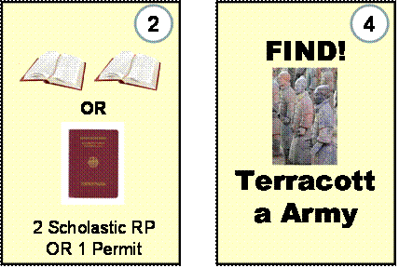
Examples of a Breakthrough (left) and a Find (right). VPs are in the upper right-hand corner

- Teach: remove Professor piece(s) and collects 1 new RA
- Scheme: pay $2 and draw 1 Scheme card. These cards can be played at your discretion, and are discarded once played. Scheme cards allow the player to sabotage other players’ efforts, and also protect against such meddling.

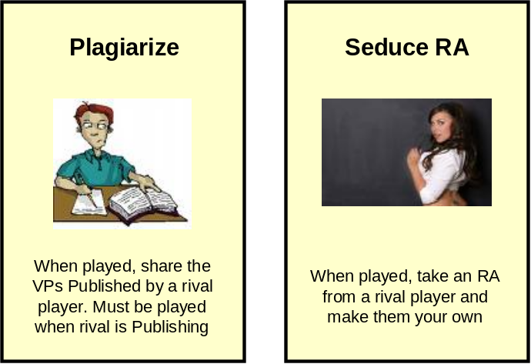
Examples of Scheme Cards

- Explore: Pay $1, remove Professor piece(s) and draw 1 Explore card. Explore cards often create encounters with monsters or challenges. When this happens, a player must roll a set number of six-sided dice. Professors start with a default of 2 dice in their dice pool, but may acquire weapons that increase their pool as the game progresses. RAs start with 1 die in their dice pool. Successes are obtained when a 5 or 6 are rolled.

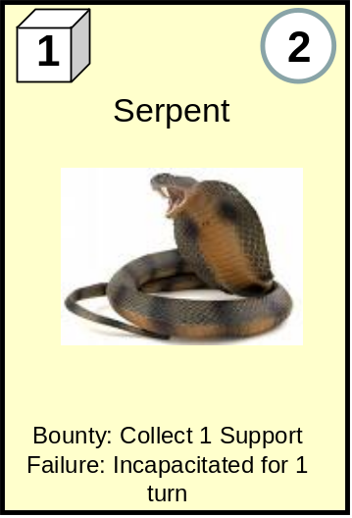
An example Explore card

In the example above, you must roll 1 success in order to win the combat. You may also try to flee. One success is required to flee unless otherwise stated. If you are victorious, collect the stated number of VPs in the right-hand corner (2 in this case), as well as the Bounty stated on the card (in this example, the Serpent yields 1 Support Resource Point). If you fail in the combat, the stated consequence must be followed as stated on the card. Players can add to their dice pools via weapons, or they can spend:

  - 1 Support or Permit RP for each extra die rolled
  - 1 Eldritch RP to an automatic success

- Publish: remove Professor piece(s) and place your Find(s) face up on the table in front of you. You may publish as many Finds as you have during this action. Collect the stated number of VPs, plus cash (1/2 of the stated VP amount). You may also “trade up” on resources as per the following: 1-1 for scholastic/field, 2-1 for anything to support, 4-1 for permits, and 8-1 for eldritch. NOTE: Legendary Finds count as 2 “slots” when published. E.g., if a player had 4 regular Finds and 1 Legendary Finds; s/he would have all 6 slots filled, and the game would end.

3.5 Heal Professor or RAs
At the end of the turn, any RAs or Professors who are incapacitated move from Incapacitated to Healing, or from Healing back to the player’s hand.

4. Game End
The game ends when the following conditions are met:

- When a player publishes 6 Finds
- OR – When the Academy Track is filled

Upon meeting these conditions, play continues to the end of the current turn. All VPs are then totaled. The player with the most victory points is the winner.

